FORKLIFT OPERATOR REFRESHER TRAINING

(English)

Company Name: ________________________________________________________________________________

Contact Person: ____________________________________ H/P: ____________________________________

Tel: ________________ Fax: _________________ Email: ______________________________________________

Address: ______________________________________________________________________________________

No. | NRIC/FIN/WP No: | Full Name | DOB | Nationality | Mobile No. | Email ID
1.
2.
3.
4.
5.

Course Fees: $190/-per participant (Excluding 9% GST)

Total course fee: $___________Payment Mode: Cash Cheque Cheque No. _____________ _ PayNow Bank Transfer
(payable to EFG Training Services Private Ltd)

Terms and conditions
- Personal information details collected is for the use ONLY for course registration, account servicing of course-related activities, course survey and / or for application of course-related funding (only if applicable)
- Course surveys shall be conducted by SSG for selected courses thru the trainees emails or contact given
- Registration forms shall be submitted 7 days before the course commencement date
- The company reserves the right to revise the course fee without prior notice, to cancel or postpone the course due to unforeseen circumstances
- Replacement and Withdrawal
- 90% refund will be made if the notice of withdrawal in writing is received by EFG at one week before the course commencement date. If such notice is received by EFG less than one week but more than three working days before the course commencement date, 75% refund will be made. No refund will be given if EFG received the notice of withdrawal 3 working days before the course commencement date. Replacement of participant is allowed if the request is made before the commencement of the course
I, the Applicant consents to the collection, use and disclosure of my personal data and training records to companies that access the Ministry of Manpower (MOM)’s Training Record System (TRS). Companies using the Check Workers’ WSH Training Records eService on the MOM website may verify my training records, including the following information:
- Identification Number (Work Permit / FIN / NRIC Number) & Name Eligibility for 4 years of Safety Orientation Course (CSOC / SSIC / MSOC certification, if applicable) & Course Title & Name of Training Provider & Date of Assessment & Certificate Expiry Date & Result of Assessment

By checking the boxes above and signing below, I confirm my consent for the disclosure of the selected information.

__________________ __________________________
Name: Signature/Date
Company Stamp
FORKLIFT OPERATOR REFRESHER TRAINING

Course Overview

- The Forklift Operator Refresher Course aims to provide trainees with the skills and knowledge required to operate a forklift safely.
- The validity period for a forklift operator is 3 years. Thereafter, forklift operators shall attend the Forklift Operator Refresher Training course once every 3 yearly (SS573:2012 for forklift retraining is every 3 years)

Course Content

- Online Training (Asynchronous e-Learning for 7 modules)

- Relevant Workplace Safety & Health (WSH) Legislations/Singapore Standards SS573, applicable to forklift operation
- Refresh on the correct interpretation of the Load Chart
- Forklift Stability
- Pre-Operational & Post Checks on a Forklift Machine
- Techniques and requirements for safe operations
- Highlights on the common safety lapses by forklift operators and the consequences.
- Safety Rules (Do’s and Don’ts)

- Workshop (In person training)

- 4 case studies
- Forklift Practical inclusive of 15 mins practical assessment
Demonstration by trainer and skills practice by learners
The trainer will explain and demonstrate the following activities:
- Prepare to carry out forklift operations
- Inspect forklift
- Carry out forklift operations
- Reinstate and handover forklift

Entry Requirement
Trainees must
- have Valid Forklift License (Candidate must submit their forklift license for verification before enrolment)
- be able to interpret work instructions and technical information
- be able to listen, speak, read and write English, and be able to process numbers at a proficiency level equivalent to Workplace Literacy and Numeracy (WPLN) Level 3, or PSLE qualification

Course Duration:
- 12 Hours (11 training hours + 1 assessment hour (theory and practical))
- Online Theory 4 hours via asynchronous e-learning covering 7 modules inclusive of 45 mins of Formative Assessment with 4 MCQs per module.
- 1 day workshop 8 hours [4 Case Study (4 hours) + Forklift Practical (4 hours inclusive of 15 mins for practical assessment per trainee]

medium of Instruction: English
Attendance: 100% for asynchronous learning and practical training cum assessment
Facilitator/Learner Ratio:
- Workshop (In person training) 1:20
- Practical 1:1 (Group of 5 trainees per forklift machine per trainer)
Training Methodology:
- Online Asynchronous e-learning and In-person workshop lecture presentation, group discussion, case studies, demonstration, practical, observation, practical assessment and feedback
Assessment Advice
- The trainee must attain 60% pass for the online formative assessment for Forklift Operator Refresher Training and 100% pass for the practical assessments to be issued the “Certificate of Successful Completion”.
- The number of attempts a candidate is allowed to be assessed in the written assessment is ONE. The candidate certified “NOT YET COMPETENT” after the assessment must be re-coursed.
Online Test: Forklift Operator Refresher Training (Asynchronous training):

- E-assessment: 30 Formative MCQs for 45 mins
Practical Assessment
Practical assessment: 15 mins/Trainee, as stated below:
- Inspect forklift machine (2 mins)
- Carry out forklift operations (11 mins)
- Parking (in & out of parking lot) (2mins)
- Manoeuvring (S and L shape) with and without load (3 mins)
- Loading and Unloading (6 mins)
- Reinstate and handover forklift (2 mins)
Practical: 1: 1 (Trainee: Trainer, Practical session)
[Group of 5 trainees to 1 Forklift/Trainer (or Assessor]

Course Fee: $ 190 (Excluded GST)
Funding & Claims: NA
Certification:
- Upon completing the E-learning 07 modules and passing the formative assessment, participants will receive a Certificate of Completion from EFG Training Services Pte Ltd and be eligible to attend the in-person Workshop, Practical training and assessment.
- Upon meeting at least 100% attendance of In-person workshop, Practical training and assessment, participants will receive a Certificate of Successful Completion from EFG Training Services Pte Ltd valid for 3 years.
FORKLIFT OPERATOR REFRESHER TRAINING

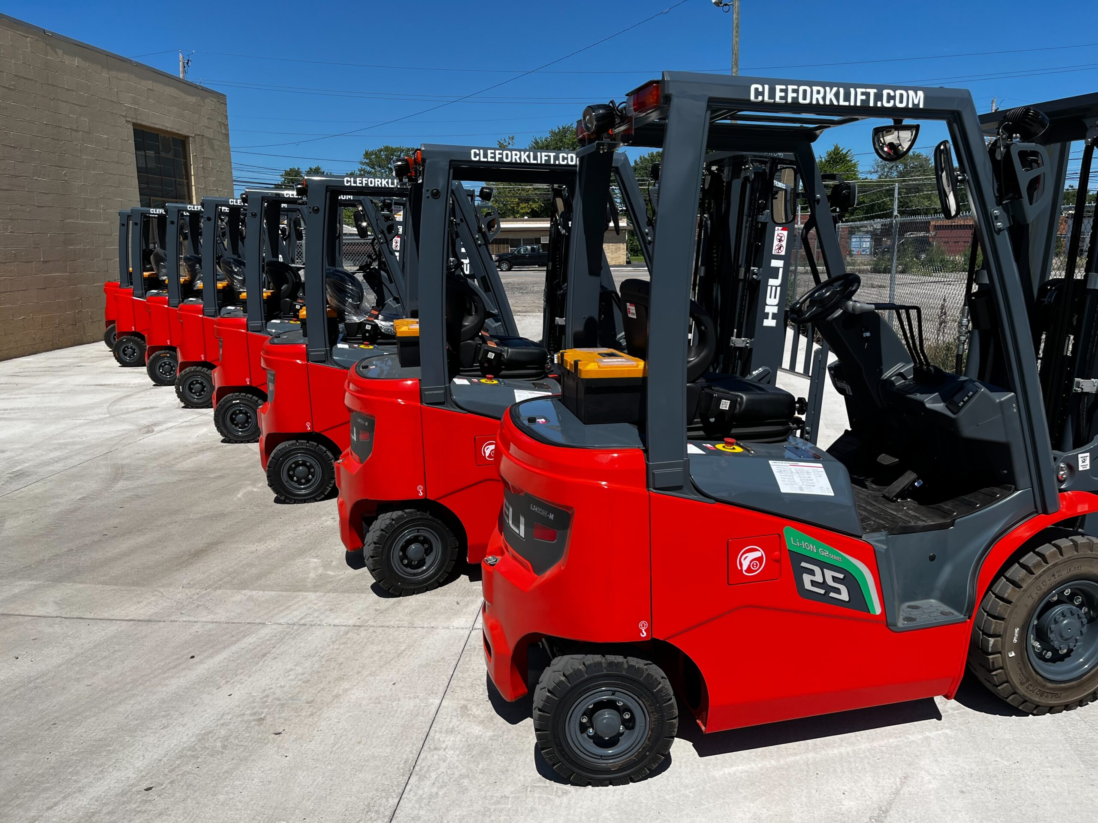

Course Venue Theory & Practical
No. 3 Soon Lee Street, #01-23 Pioneer Junction, Singapore 627606.

EFG TRAINING SERVICES PRIVATE LTD
Learning service PROVIDER by gic
No: 3 Soon Lee Street
# 01-16 Pioneer Junction
Singapore 627606

Ways to register
TEL: 6334-7872
FAX: 6334-7891
E-mail: admin@efg.com.sg
No: 3 Soon Lee Street
# 01-16 Pioneer Junction
Singapore 627606

Website:www.efg.com.sg

